What is Grit?
GATE Group-September 2014
- I began our session today by asking the students to brainstorm the following question:
“What is “grit”?

- After brainstorming, I shared the dictionary definition:

The dictionary defines “grit” as:
Courage, strength of character, bravery, spirit, determination, perseverance, endurance, spunk

- We discussed the words from the definition and then I asked, “Who do you know that has “grit?” “Do you think it’s important to have ‘grit’?” “Why? “How do our PBIS goals go along with our “grit” thinking?”

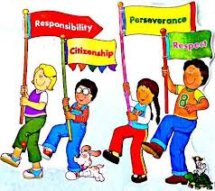
- I told the students that this year’s theme for all of our GATE Group sessions is going to be: “GRIT”. We will take a different descriptor of “grit” each month and think about how we can use that type of “grit” in our lives.
- We then added some movement to our session by “grooving to the music video, “Don’t Give Up”, by Bruno Mars https://www.youtube.com/watch?v=pWp6kkz-pnQ
–
- I ended our session by handing each student a “What is Grit?” poster, and we reviewed the descriptors for “grit”: Courage, Determination, Perseverance, Endurance, and Spunk. I also had two levels of sandpaper stapled to the poster, and I asked the students to share with me, what level of “grit” they would want to show at school, at home, and in the community?

I asked each student to find a special place to hang the “What is Grit?” poster, so they would constantly be reminded that “grit” is an awesome characteristic. A characteristic that they will want to share with others!!

Parents, if you are interested in learning a bit more about this topic, please follow the link below:
http://www.gostrengths.com/what-is-grit/

